Random Signal Analysis Project

Group Members

I. TROPICAL DEPRESSION TARGETS DETECTION

A. Problem Statement
A Tropical Depression (TD) is the early development stage of destructive tropical cyclones such as typhoons. Early and accurate detection and center positioning of them are of significant practical importance for meteorological early warning and disaster prevention and mitigation. However, during the nascent stage of tropical cyclone development, their cloud structures are often irregular and lack clear eye features, which poses a great challenge to traditional physical geometric model matching algorithms [1][2].

This course project aims to guide students in using deep learning or other algorithms, combined with satellite remote sensing data, to formulate and investigate a well-defined problem related to the detection, evaluation and/or prediction of tropical depression.

B. Dataset
The geographical range of the image data is uniformly 15°S-55°N, 109°E-179°E, with a pixel size of 640×640, containing two different modalities of satellite remote sensing images and their corresponding annotation files:

- Infrared Remote Sensing Data: The raw data comes from the Advanced Himawari Imager (AHI) aboard the geostationary meteorological satellites Himawari-8/9. This project selects data from Channel 13 (central wavelength 10.4µm) as the infrared data source, primarily used to observe the features of typhoon cloud systems.
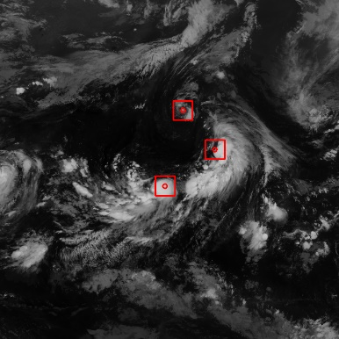
- Microwave Remote Sensing Data: The raw data comes from the Advanced Technology Microwave Sounder (ATMS) aboard the polar-orbiting satellite Suomi-NPP (S-NPP). This project provides data from Channels 2, 3, 4, 5, 6, 7, 16, and 18, with central wavelengths of 31.4 GHz, 50.3 GHz, 51.76 GHz, 52.8 GHz, 53.596±0.115 GHz, 54.4 GHz, 88.289 GHz, and 182.32±7 GHz, respectively. That is, one microwave sample corresponds to 8 channels of data, mainly used to observe the circulation structure of various layers inside the typhoon. Note that due to the operational characteristics of polar-orbiting satellites, microwave data suffer from spatial data gaps and temporal discontinuity issues, so the sample size of the microwave dataset is about half that of the infrared data.
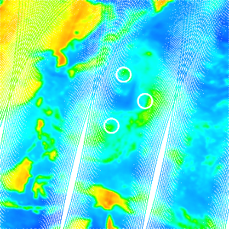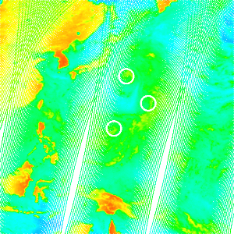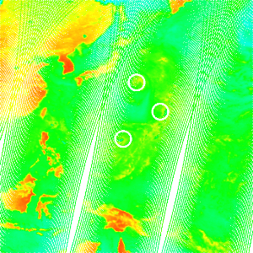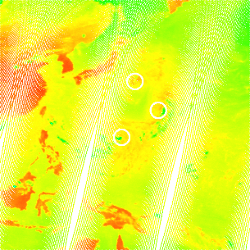
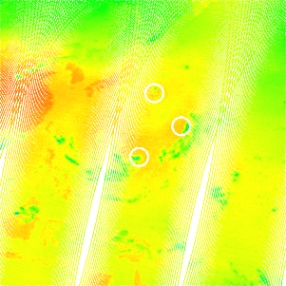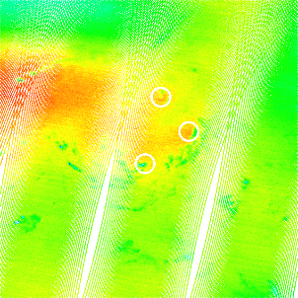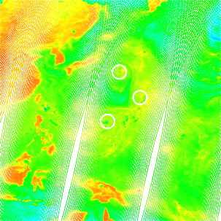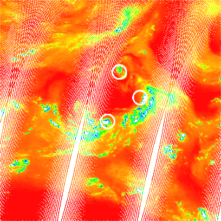

- Other approved data: The ground truth center positions of TD targets are generated based on the best track dataset published by the RSMC Tokyo-Typhoon Center. This project provides target center point labels as well as derived bounding box labels. The bounding box annotation strategy generates a fixed-size 5°×5° bounding box using the center as a reference. The labels are provided in YOLO format and COCO format.

C. Project Tasks and Evaluation Metrics
Explain the tasks you defined in the project, and introduce some measurable metrics that you selected or defined for this task to adapt to it.

Such as precision, recall, F1-score, or FROC analysis for detection, euclidean distance error for center localization, MAE , RMSE for prediction or estimation.

When using the threshold, it should be clearly explained according to the task requirements. As a reference, for the detection task, a center point decision threshold of 3° and a bounding box IoU threshold of 0.2 can be considered.

D. Proposed Methods
Please describe the methods you have chosen to accomplish the proposed task, and explain the reasons for your design choices.

E. Results Analysis
Please numerically show the performance of the proposed methods and compare it with other baseline algorithms (if any).

II. CONCLUSIONS
Please summarize the proposed methods and their performance evaluation results. You can also discuss any improvement that can be made as future work.

References
[1] H. Wang, Q. Xu, X. Yin, and Y. Cheng, “Determination of low-intensity tropical cyclone centers in geostationary satellite images using a physics-enhanced deep-learning model,” IEEE Trans. Geosci. Remote Sens., vol. 62, pp. 1–10, 2024, doi: 10.1109/TGRS.2024.3363842.
[2] X. Tian, L. Yang, C. Bi, and C. Yu, “OFMAD-TC: A tropical cyclone detection method with optical flow and morphology awareness,” Neurocomputing, vol. 662, p. 131936, Jan. 2026, doi: 10.1016/j.neucom.2025.131936.

Note: Please delete the text in red font in the formal report.

